**16.How to handle exception while file handling in python?**

**Objective:**

* To handle the exception while handling the file using python3.

**Process:**

* Try
* Except
* Finally

**Input:**

* Text file.

**Output:**

* Exception handled file.

**Some types of error:**

**IOError**

If the file cannot be opened.

**ImportError**

If python cannot find the module.

**ValueError**

Raised when a built-in operation or function receives an argument that has the right type but an inappropriate value.

**KeyboardInterrupt**

Raised when the user hits the interrupt key

(normally Control-C or Delete).

**EOFError**

Raised when one of the built-in functions (input() or raw_input()) hits an end-of-file condition (EOF) without reading any data.

**Source code:**

**#in this sample we are going to see IOError and how to handle that.**

#read a file using loop and readlines()

#os package for detect the file directory

import os

os.chdir('/home/soft27/.config/spyder-py3')

#exception handling when file is not in the directory

try:

list=[]

for line in open('read_it.txt','r').readlines():

list.append(line)

#slicing

list=list[0:10]

str1=''.join(list)

print("-----IOError-----")

print(str1)

#IOError handling

except IOError as e:

print("file missing({})".format(e))

**Screen shots:**

**File not found error:**

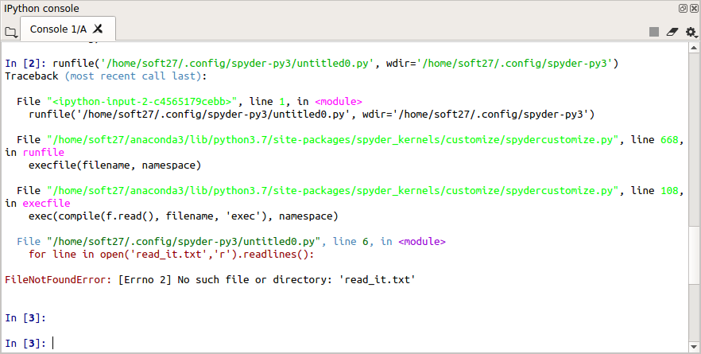

**Exception handling:**

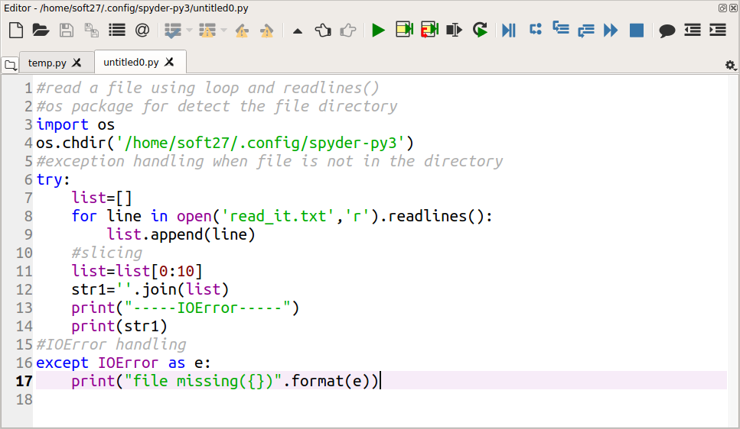

**Output:**

